|  |  |
| --- | --- |
| **IREVOLUTION-APPLE’S IPHONE IMPACT IN INDIA** | ABSTRACT  the project aims to analyze the influence of apple’s iphone in the indian smartphone market by utilizing data analysis techniques and visualization tools like tableau  TeAM ID –  team-7   * cindurasri t.l * anisha priyadarshini.r * cheryll evangeline stephen * dasari swetha |

1.**INTRODUCTION**

1.1 **Project Overview**

Development of an Apple smartphone began in 2004, when Apple started to gather a team of 1,000 employees led by hardware engineer Tony Fadell, software engineer Scott Forstall, and design officer Jony Ive to work on the highly confidential “Project Purple”

In order to shed light on important factors like market penetration, customer preferences, economic ramifications, and societal changes, this research report will perform a data driven investigation of the impact of the iPhone in India. This study will offer invaluable insights into the transformative impact of the iPhone on India's technological landscape and the lives of its consumers by using advanced data analytics techniques and analyzing large datasets.

1.2 **Purpose**

Apple has started assembling the iPhone 14 in India, according to reports from TechCrunch and Bloomberg. This marks the first time Apple has shifted production from China to India this quickly after the launch of a new iPhone.

**2.LITERATURE SURVEY**

* 1. **Existing problem**

The existing literature reveals several key challenges and issues related to the impact of Apple's iPhone in India. These challenges can be summarized as follows:

* Affordability and Market Penetration:
  + Research indicates that the high price point of iPhones poses a significant barrier to widespread adoption in India, especially among price-sensitive consumers.
  + Studies highlight the need for Apple to address affordability concerns and offer more competitive pricing strategies to penetrate the Indian market effectively.
* Localization and Regional Preferences:
  + Cultural and regional preferences in India play a crucial role in consumer choices. The existing literature emphasizes the need for Apple to understand and cater to these preferences through localized features, content, and marketing strategies.
  + Researchers suggest that customization and localization efforts by Apple should go beyond language translation to include region-specific apps, services, and user experiences.
  1. **Problem Statement Definition**

The objective of this study is to obtain a thorough understanding of how Apple's iPhone would affect the Indian market. In particular, we want to investigate the market penetration of iPhones in India, comprehend consumer preferences and decision-making processes, and assess the social and economic effects of iPhone adoption. We aim to offer insights that can direct strategic decisions for Apple and other stakeholders active in the Indian smartphone industry by leveraging data analytics and visualizations using Tableau.

1. **IDEATION & PROPOSED SOLUTION**
   1. **Empathy Map Canvas**

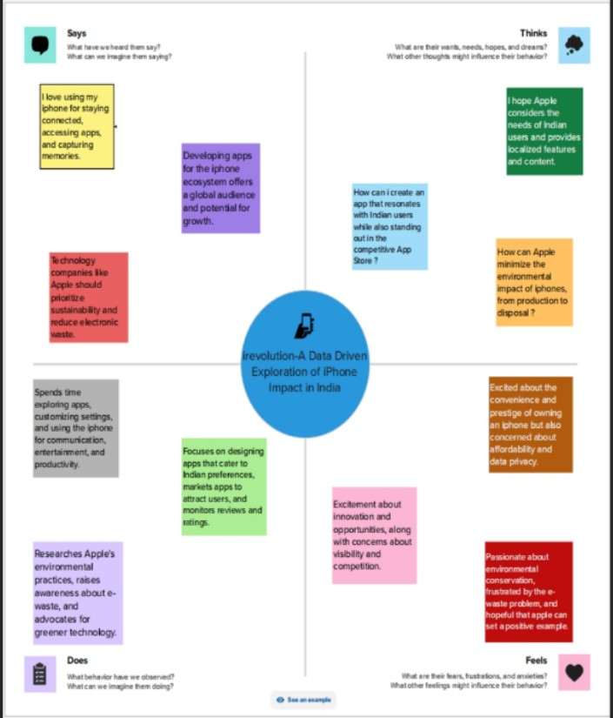

* 1. **Ideation & Brainstorming**

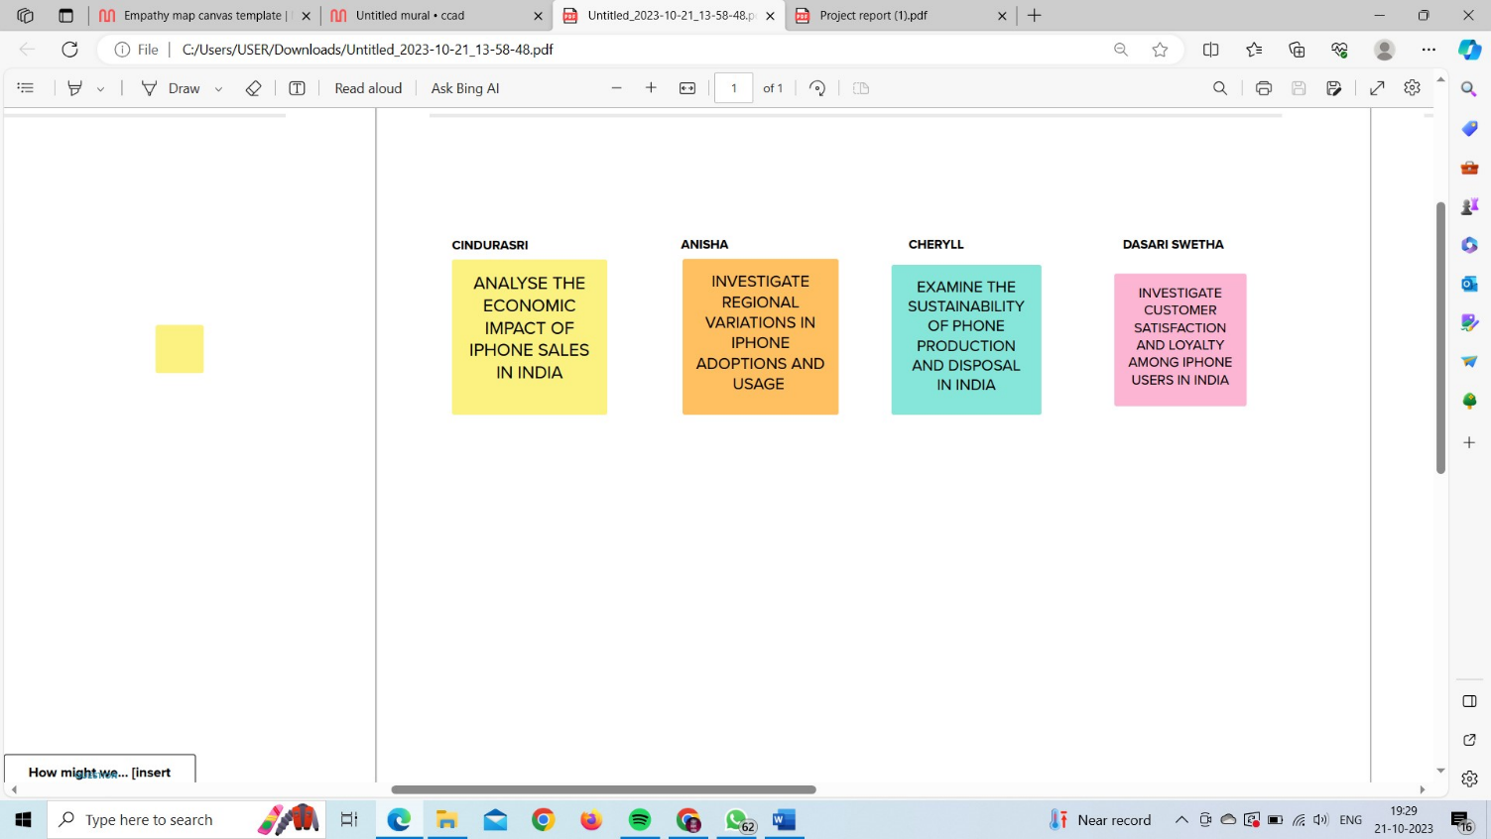

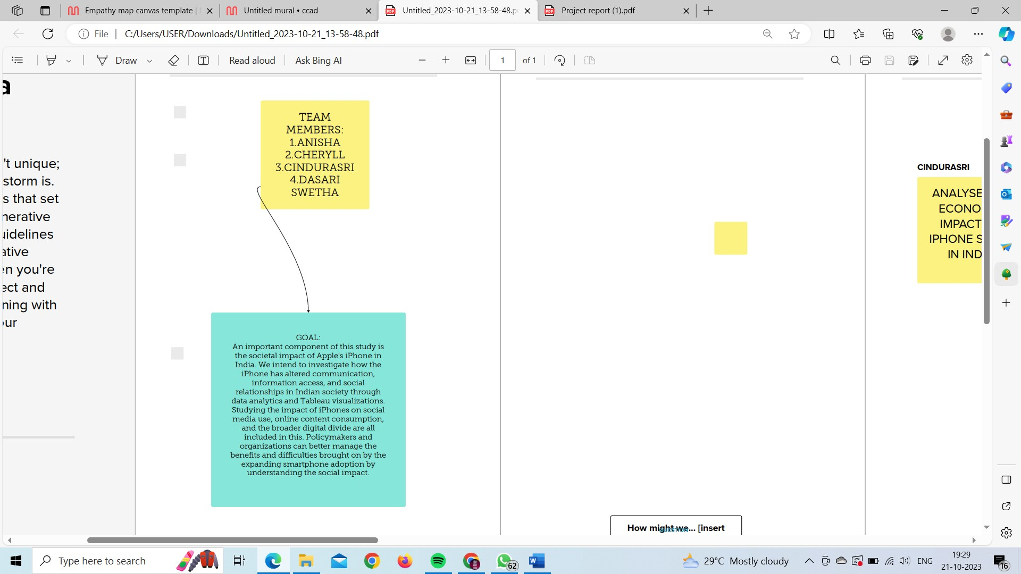

1. **REQUIREMENT ANALYSIS**
   1. Functional requirement

* Data Collection and Storage:Collect and store relevant data on Apple's iPhone sales, market share, pricing, and customer demographics in India.
* Data Analysis and Visualization:Implement data analysis tools and algorithms to process and analyze the collected data.Create interactive and visually appealing data visualizations, such as charts, graphs, and maps, to represent key findings.Develop dashboards for users to explore and interact with the data.
* User Authentication and Authorization:Implement user authentication and authorization to control access to sensitive data and features.Differentiate between various user roles (e.g., admin, researcher, viewer) with appropriate permissions.
* Search and Filter Functionality:Allow users to search and filter data based on various criteria, such as location, time period, product model, and economic indicators.Enable advanced filtering options to refine data queries.
* Reporting and Exporting:Provide the capability to generate and export custom reports
  1. Non-Functional requirements
* Performance:* Response Time: The system should have fast response times for data queries and visualization rendering. * Load Testing: Perform load testing to ensure the system can handle peak user loads.
* Security:* Data Encryption: Ensure that data in transit and at rest is encrypted to protect sensitive information.* Authentication and Authorization: Implement strong user authentication and authorization mechanisms to prevent unauthorized access to data.* Data Privacy: Comply with data privacy regulations and protect user data privacy.* Security Audits: Regularly conduct security audits and penetration testing.
* Reliability:The system should be highly reliable and available with minimal downtime. Implement backup and disaster recovery mechanisms to prevent data loss.
* Usability:The user interface should be intuitive and user-friendly.Conduct usability testing to ensure that users can easily navigate and interact with the system.

1. **PROJECT DESIGN**
   1. Data Flow Diagrams & User Stories

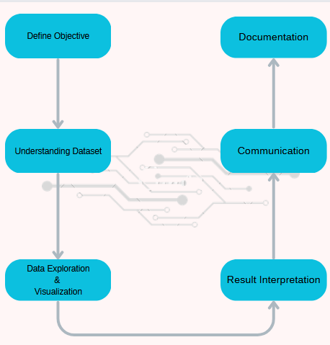

1. **PROJECT PLANNING & SCHEDULING**
   1. Technical Architecture

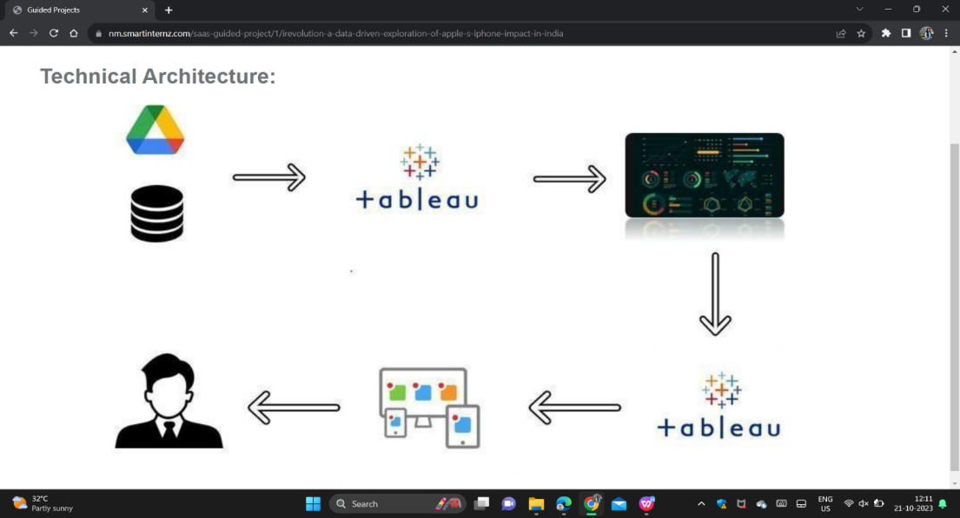

1. **PERFORMANCE TESTING**
   1. **Performance Metrics**

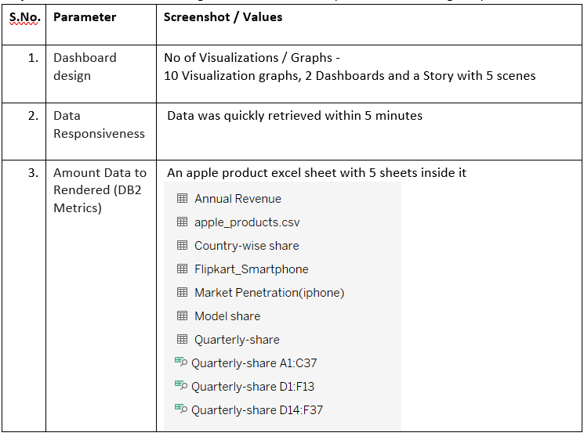

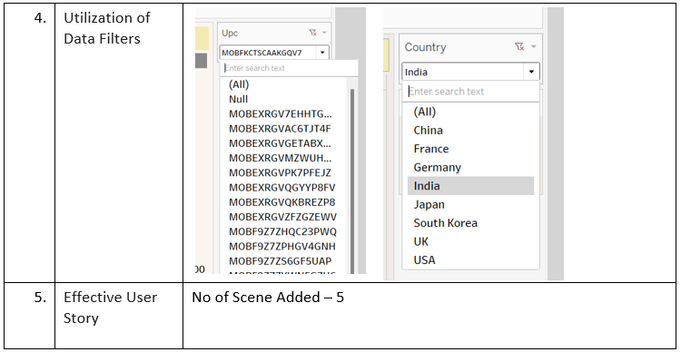

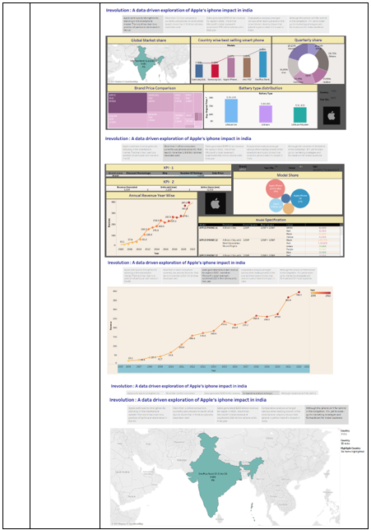



**8.RESULTS**

Output Screenshots

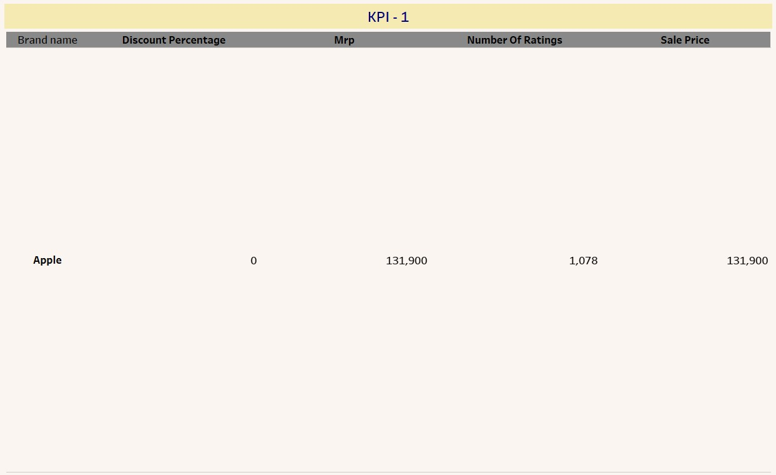

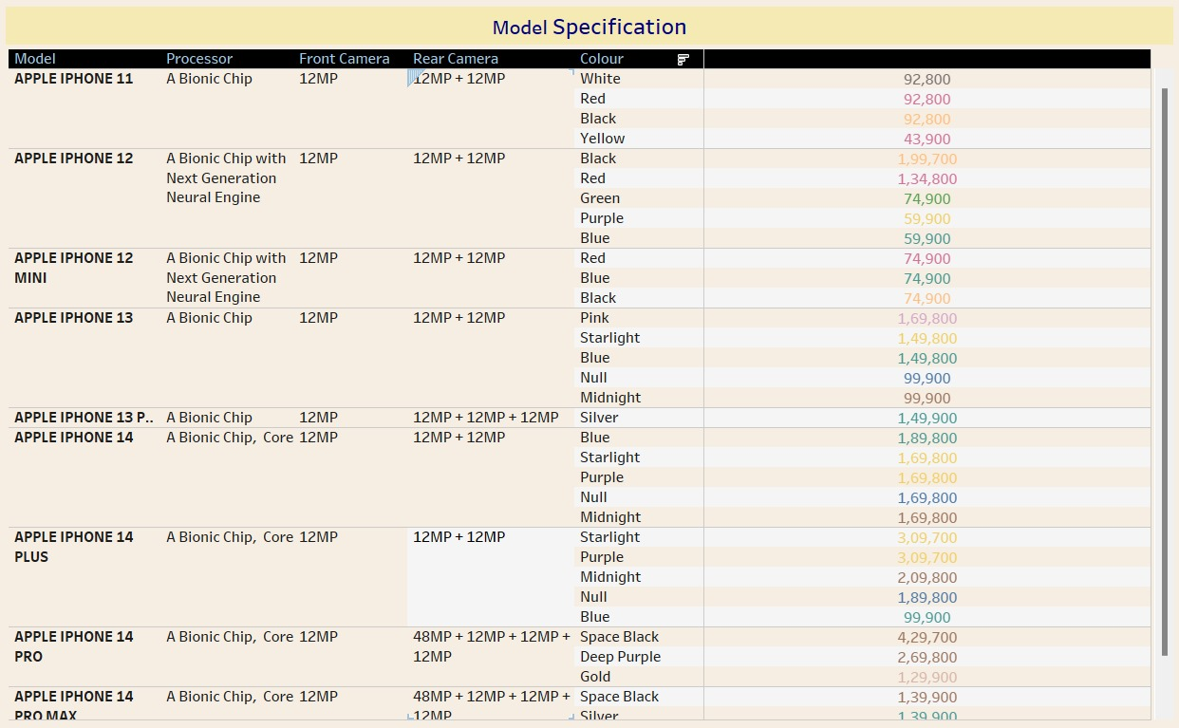

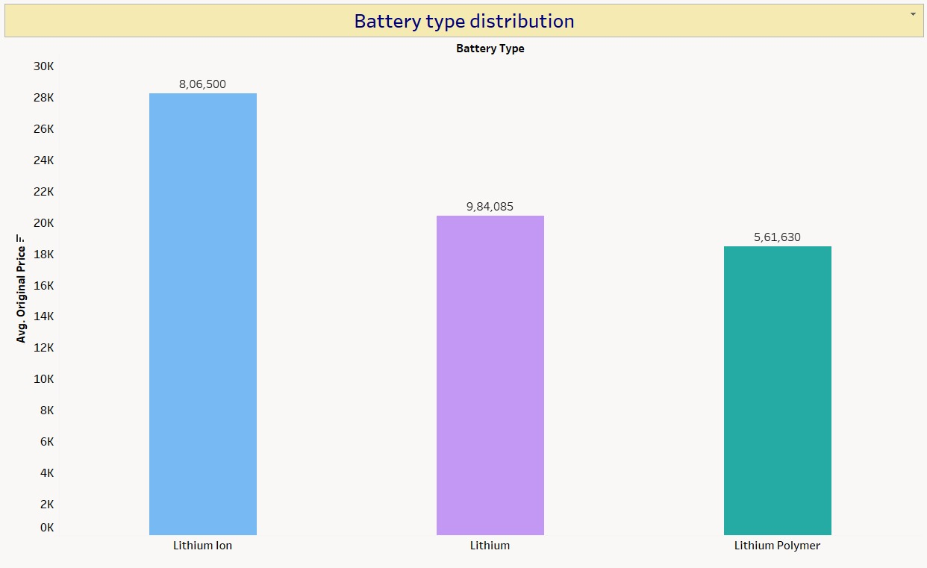

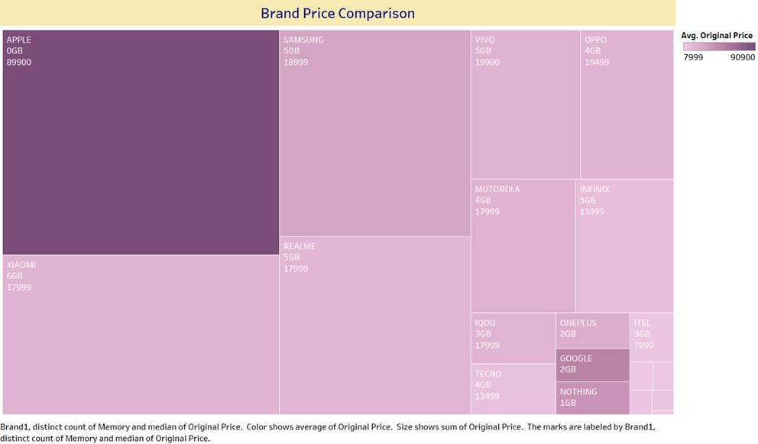

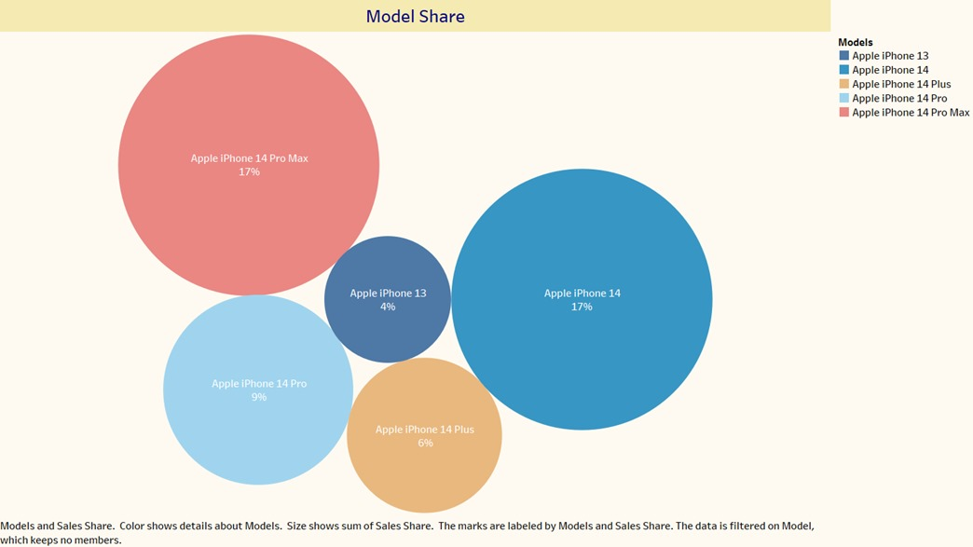

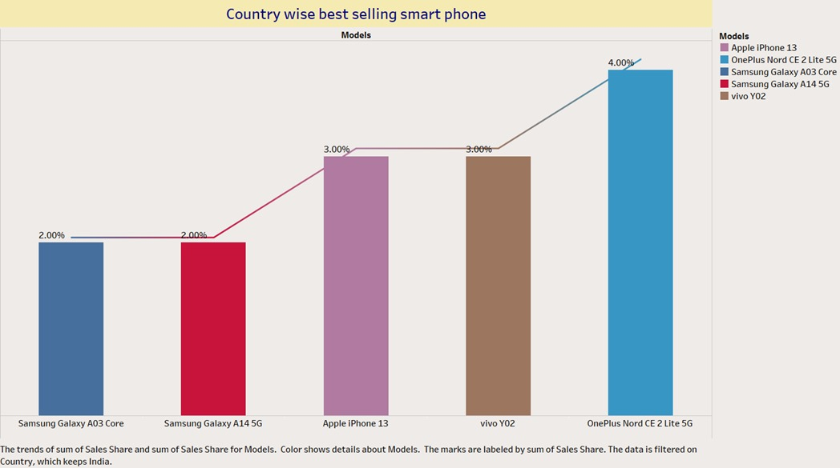

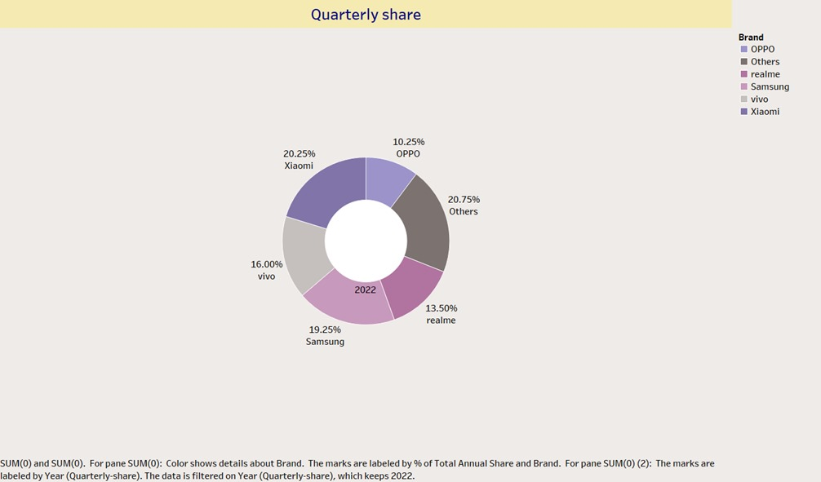

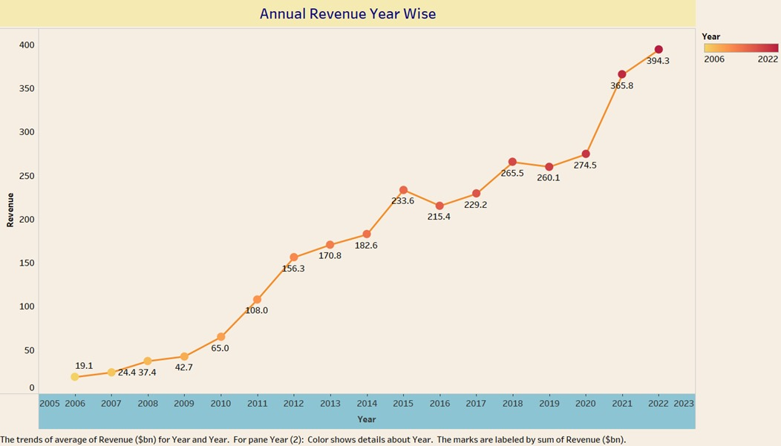

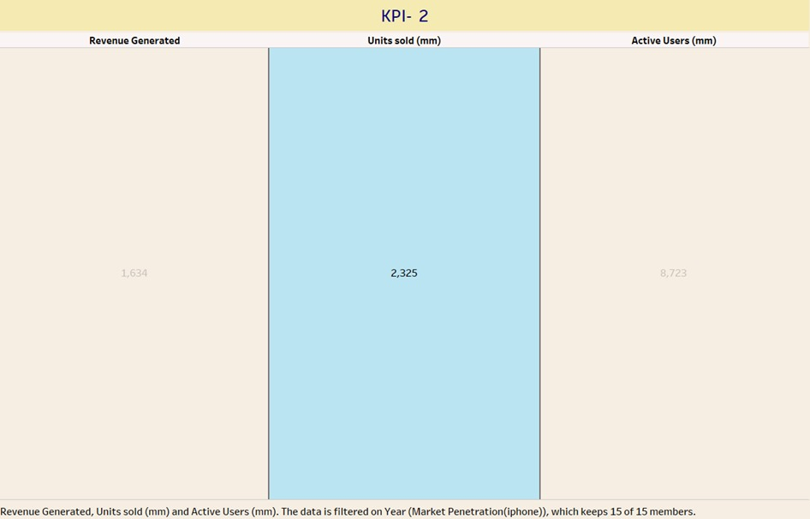

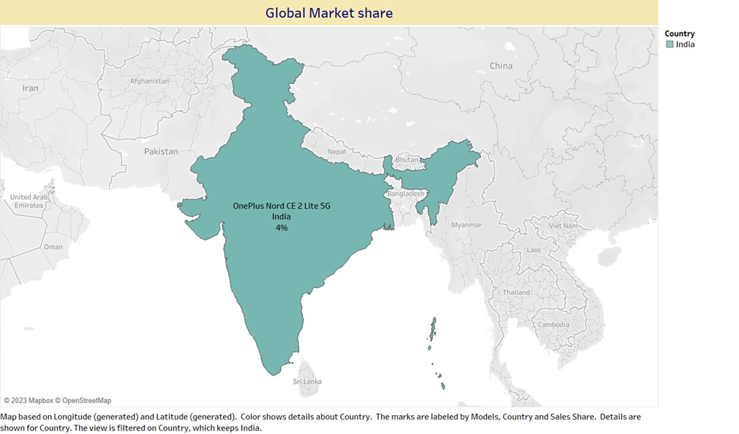

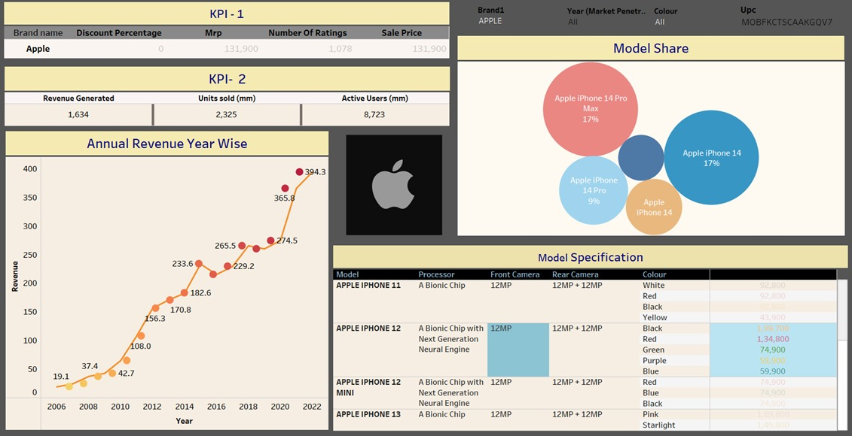**DASHBOARD:**

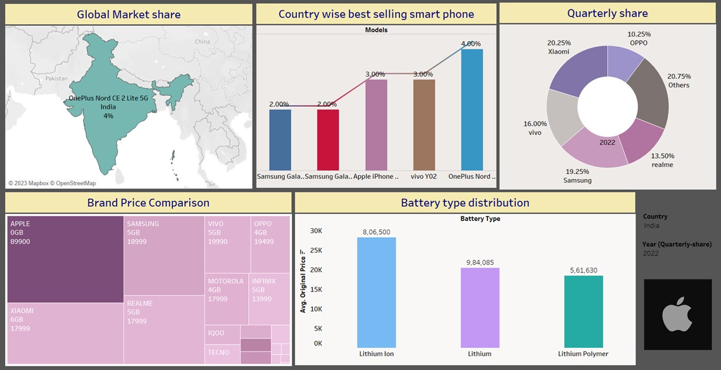

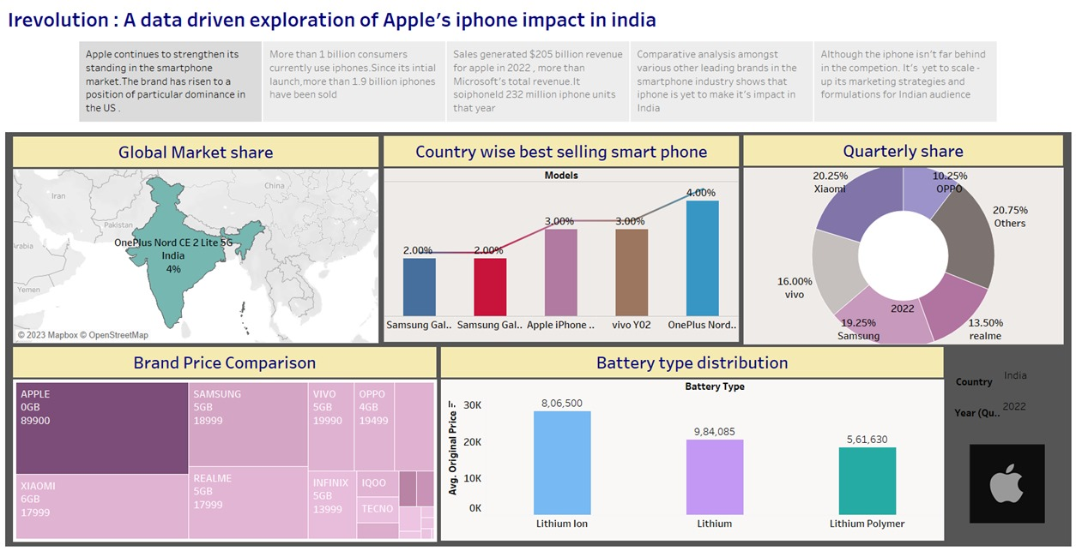**STORY:**

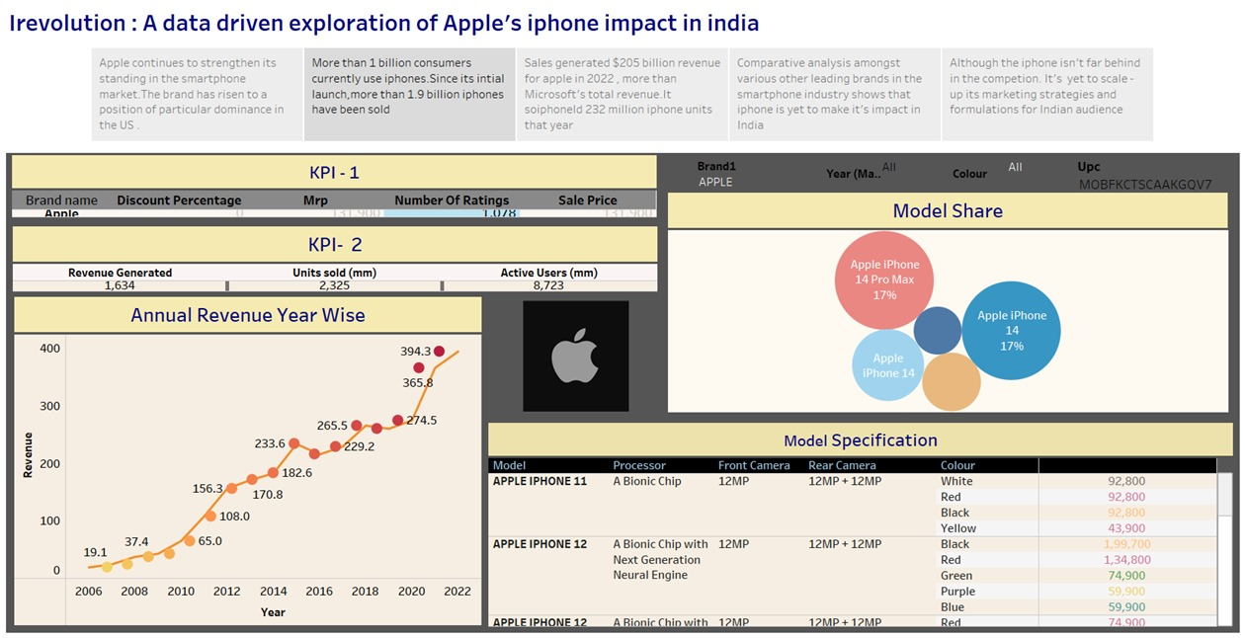

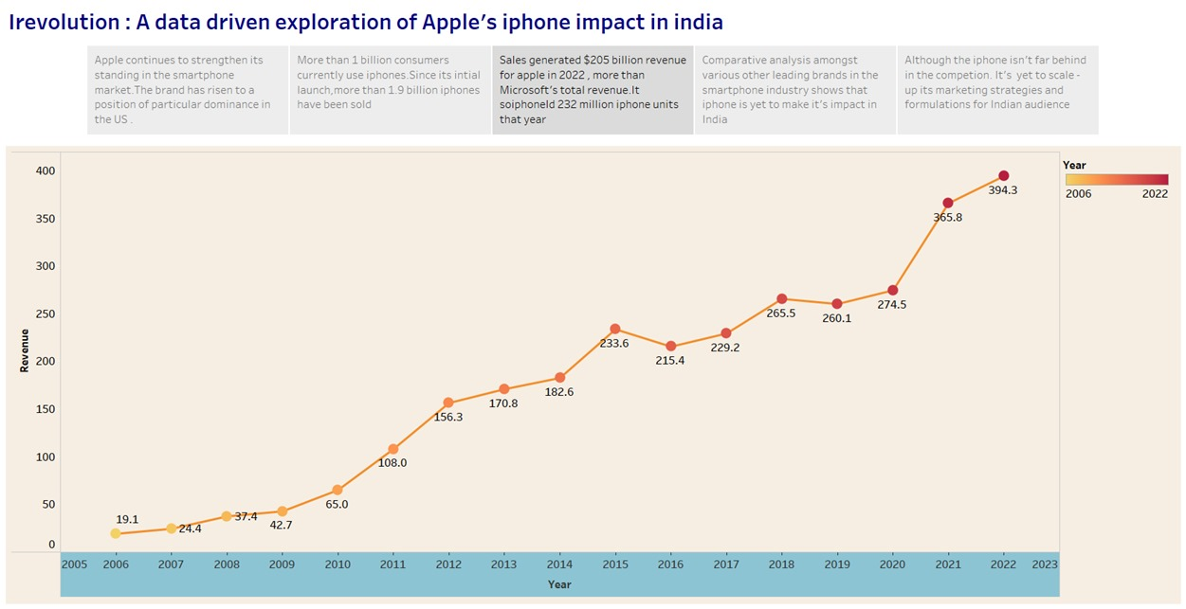

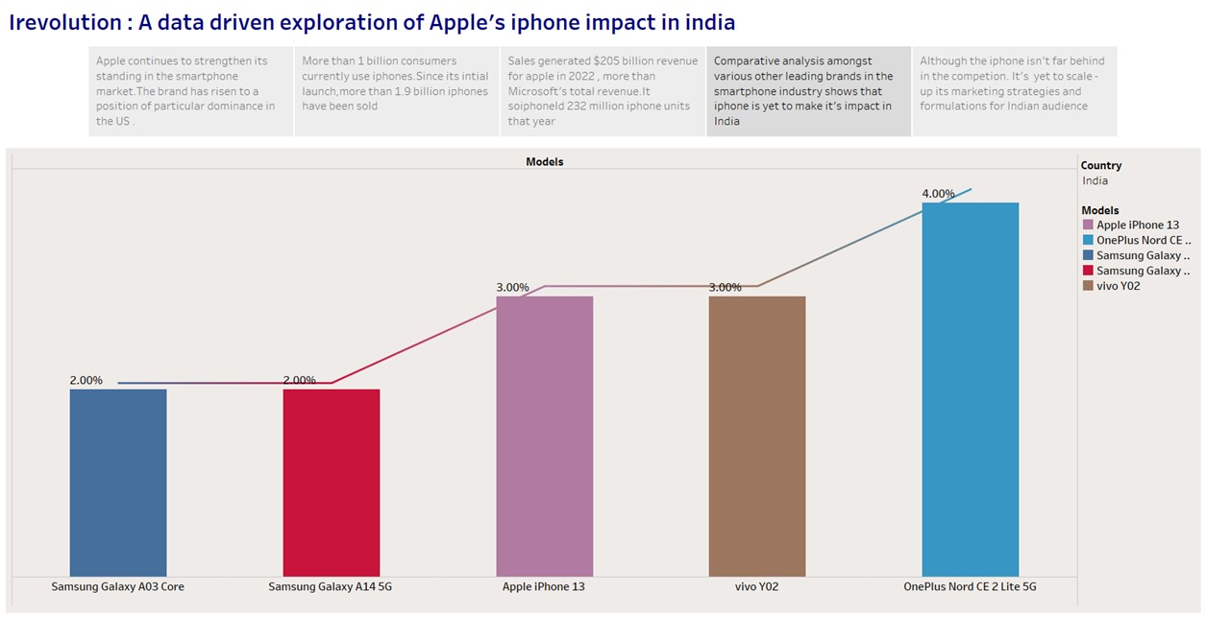

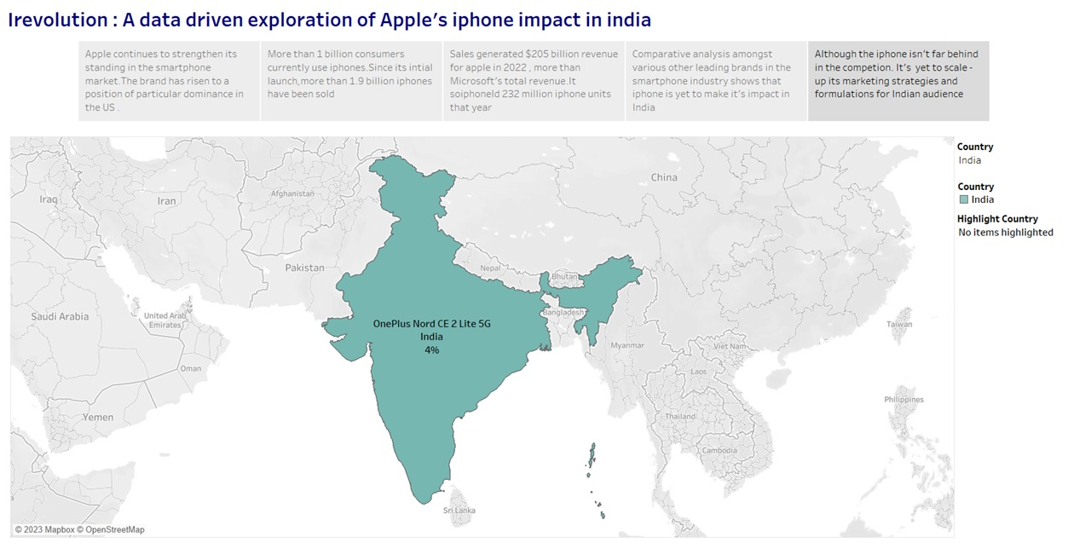

1. **ADVANTAGES & DISADVANTAGES**

Advantages:

* **Comprehensive Visualization**: The use of various visualizations, such as treemaps, horizontal bar graphs, pie charts, scatter plots, and Gantt charts, allows for a comprehensive representation of the data. This enables better understanding and interpretation of the relationships and patterns among different variables, such as brand name, product name, sales prices, RAM, MRP, reviews, and star ratings.
* **Clear Presentation of Relationships:** The visualizations effectively present the relationships between different variables, making it easier to identify correlations and trends. For example, the treemap visualization shows the relationship between brand name, product name, and sales prices, providing a clear overview of the market landscape.
* **Easy Identification of Patterns:** The visualizations aid in the identification of patterns and insights that might be difficult to discern from raw data alone. For instance, the horizontal bar graph helps to visualize the interrelationships among product RAM, product name, and maximum retail price (MRP), making it easier to identify price variations based on RAM specifications

Disadvantages

* **Limited Contextual Information:** The analyzed data may lack contextual information, such as market conditions, competitor analysis, or consumer preferences, which could provide a deeper understanding of the findings. Additional data sources and research would be necessary to augment the existing analysis.
* **Potential Biases:** The analyzed data may be subject to inherent biases, such as selection bias or response bias, depending on the data collection methods and sources. These biases could affect the accuracy and generalizability of the findings, and thus need to be considered when interpreting the results.
* **Data Limitations:** The analyzed data may have limitations in terms of sample size, representativeness, or data quality. These limitations can impact the reliability and validity of the findings and should be taken into account when drawing conclusions or making decisions based on the analyzed data.
* **Interpretation Challenges:** Interpreting the visualizations and drawing meaningful insights may require domain knowledge and expertise. Without a proper understanding of the context and variables involved, there is a risk of misinterpretation or drawing incorrect conclusions from the visualized data.

1. **CONCLUSION**

The iPhone's impact in India has been nothing short of transformative, reshaping the smartphone market and capturing the aspirations of millions of consumers. As a symbol of status and prestige, the iPhone has influenced consumer behavior and played a significant role in Apple's revenue growth in India.

The findings from the data analysis using Tableau visualizations have provided valuable insights into the market dynamics, pricing strategies, consumer preferences, and product popularity. These insights can guide strategic decision-making for brand positioning, marketing campaigns, and pricing strategies. The comprehensive visual representations have facilitated a deeper understanding of the relationships among variables, enabling evidence-based decision-making.

Notably, the iPhone has contributed to Apple's financial success in India, with the country emerging as a crucial market for the company. The demand for iPhones has been remarkable, prompting Apple to diversify its product range and distribution channels to cater to the diverse needs and preferences of Indian consumers.

The iPhone has also had a significant impact on India's digital ecosystem, fostering app development and creating a vibrant landscape of mobile applications. Additionally, Apple's commitment to affordability has expanded the iPhone's reach in India. By implementing various pricing strategies, financing options, and trade-in programs, Apple has made iPhones more accessible to a broader range of Indian consumers, driving smartphone adoption and technological advancement.

However, it is important to recognize India's diverse market landscape and the ongoing need for affordability to cater to a wider consumer base. Apple's continued success in India will depend on adapting to local requirements, fostering innovation, and maintaining a customer-centric approach. Continuous monitoring of consumer behavior and market trends will be crucial for staying competitive and responsive to evolving demands.

While the findings are based on the available data and chosen visualizations, it is essential to acknowledge their limitations and potential biases. Further research, data collection, and analysis can help validate and expand upon the insights gained. With a focus on understanding the dynamic Indian market, Apple can continue to solidify its position and contribute to India's ongoing digital transformation.

**10. FUTURE SCOPE**

Longitudinal Study: Conducting a longitudinal study to track the evolving impact of Apple's iPhone in India over an extended period would provide valuable insights into the changing dynamics of the market. This would enable the identification of emerging trends, consumer preferences, and technological advancements, allowing for a deeper understanding of the iPhone's sustained impact.

Comparative Analysis with Competitors: Expanding the scope of the project to include a comprehensive comparative analysis of Apple's iPhone with its major competitors in the Indian market would offer a broader perspective. This would involve examining factors such as pricing strategies, market share dynamics, customer satisfaction, and innovative features introduced by rival brands.

Sustainability and Environmental Impact: Evaluating the environmental sustainability practices of Apple's iPhone, such as the use of recycled materials, energy efficiency, and recycling programs, would be relevant. Assessing the environmental impact and carbon footprint of the iPhone throughout its lifecycle would contribute to understanding its sustainability credentials and identifying areas for further improvement.

**11. APPENDIX**

GitHub & Project Demo Link

Github link –

https://github.com/cindurasri/Naan-Mudhalvan

Drive link -

https://drive.google.com/drive/folders/12K4YUNzWipiWL0TVkEx22Lg6fKThoYrr?usp=share_link

THANK YOU